1. **Size of fundamental data types**

#include <iostream>

using namespace std;

int main() {

cout<<"size of char: "<<sizeof(char)<<"bytes"<<endl;

cout<<"size of int: "<<sizeof(int)<<"bytes"<<endl;

cout<<"size of bool: "<<sizeof(bool)<<"bytes"<<endl;

cout<<"size of float: "<<sizeof(float)<<"bytes"<<endl;

cout<<"size of short int: "<<sizeof(short int)<<"bytes"<<endl;

cout<<"size of long int: "<<sizeof(long int)<<"bytes"<<endl;

cout<<"size of double: "<<sizeof(double)<<"bytes"<<endl;

cout<<"size of long double: "<<sizeof(long double)<<"bytes"<<endl;

cout<<"size of void: "<<sizeof(void)<<"bytes"<<endl;

cout<<"size of long long int: "<<sizeof(long long int)<<"bytes"<<endl;

return 0;

}

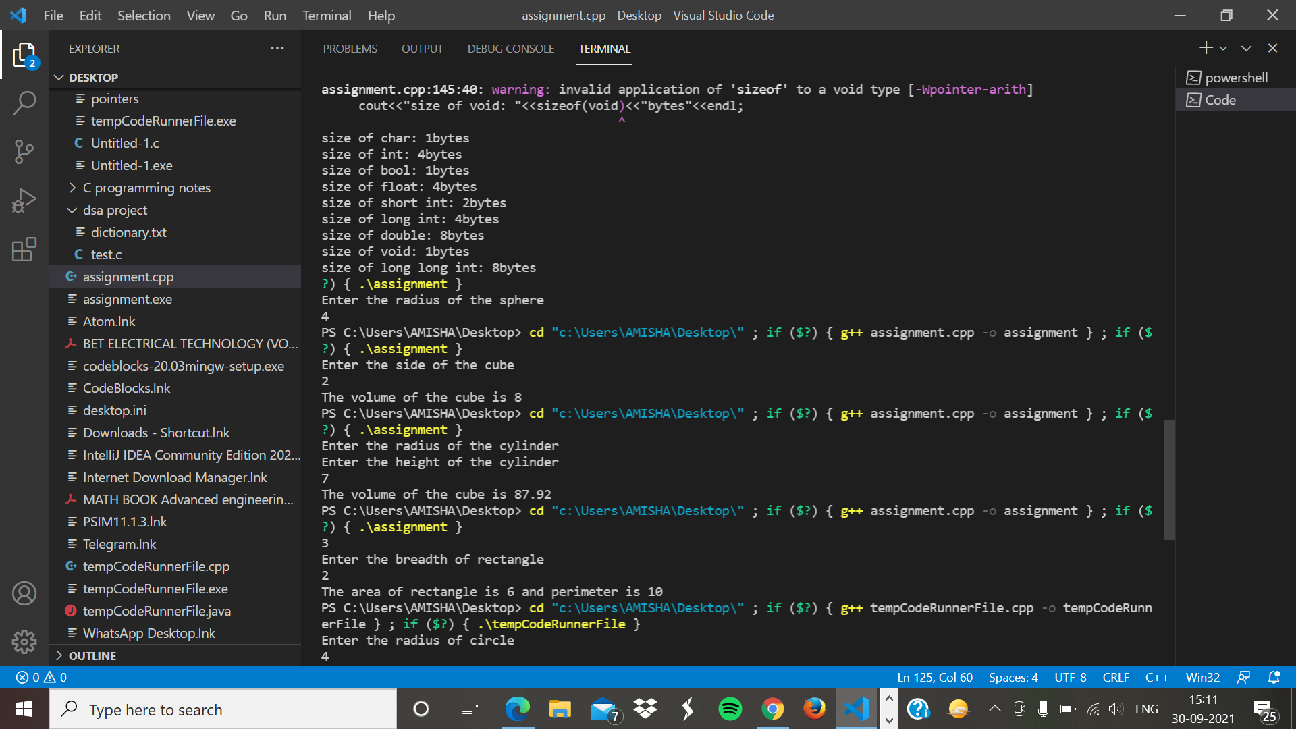

1. **Volume of sphere**

#include<iostream>

using namespace std;

int main(){

int r;

cout<<"Enter the radius of the sphere"<<endl;

cin>>r;

float pi = 3.14F;

float volume = (4*pi*r*r*r)/3;

cout<<"The volume of sphere is "<< volume <<endl;

return 0;

}

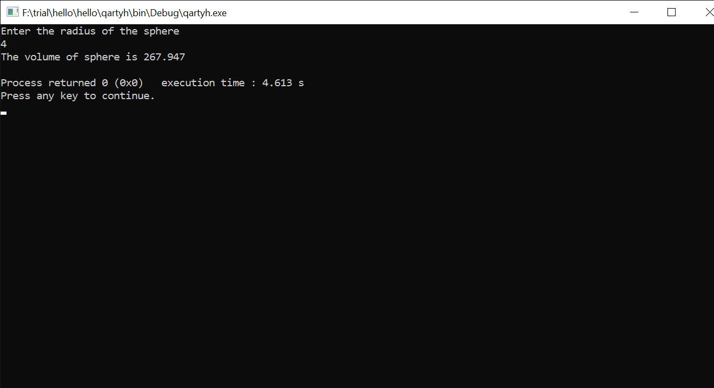

1. **Volume of cube**

#include <iostream>

using namespace std;

int main()

{

int a;

cout<<"Enter the side of the cube"<<endl;

cin>>a;

int volume = a*a*a;

cout<<"The volume of the cube is "<< volume << endl;

return 0;

}

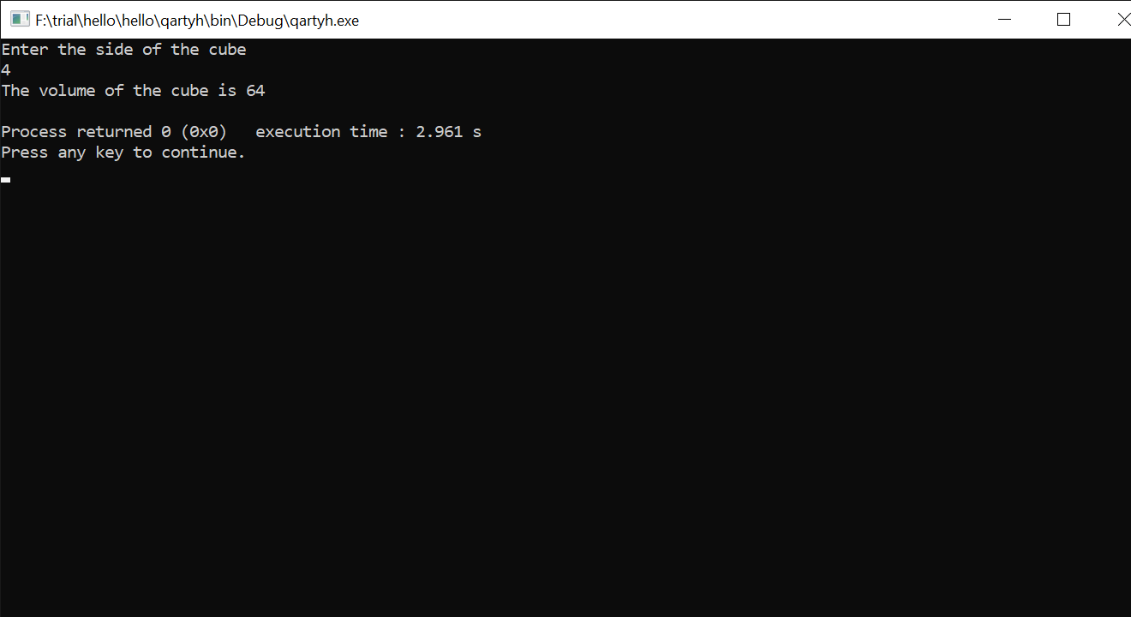

1. **Volume of cylinder**

#include <iostream>

using namespace std;

int main()

{

int r,h;

cout<<"Enter the radius of the cylinder"<<endl;

cin>>r;

cout<<"Enter the height of the cylinder"<<endl;

cin>>h;

float pi = 3.14;

float volume = pi*r*r*h ;

cout<<"The volume of the cube is "<< volume << endl;

return 0;

}

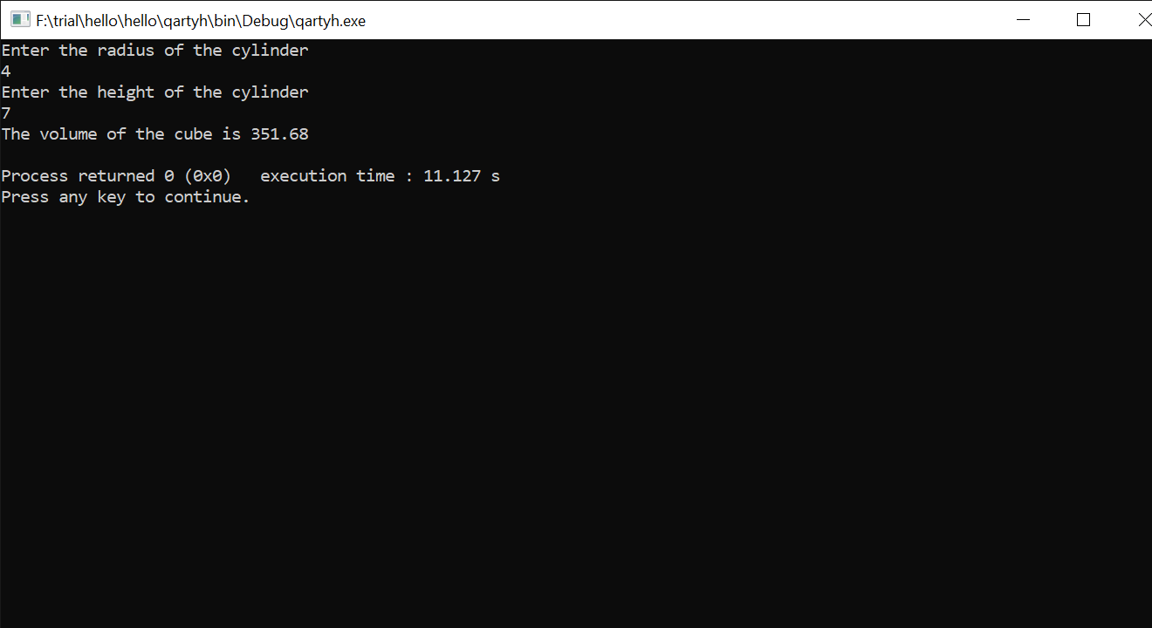

1. **Area and perimeter of rectangle**

#include <iostream>

using namespace std;

int main()

{

int a,b;

cout<<"Enter the lenght of rectangle"<<endl;

cin>>a;

cout<<"Enter the breadth of rectangle"<<endl;

cin>>b;

int area = a*b;

int perimeter = 2*(a+b);

cout<< "The area of rectangle is "<< area << " and perimeter is "<<perimeter<<endl;

return 0;

}

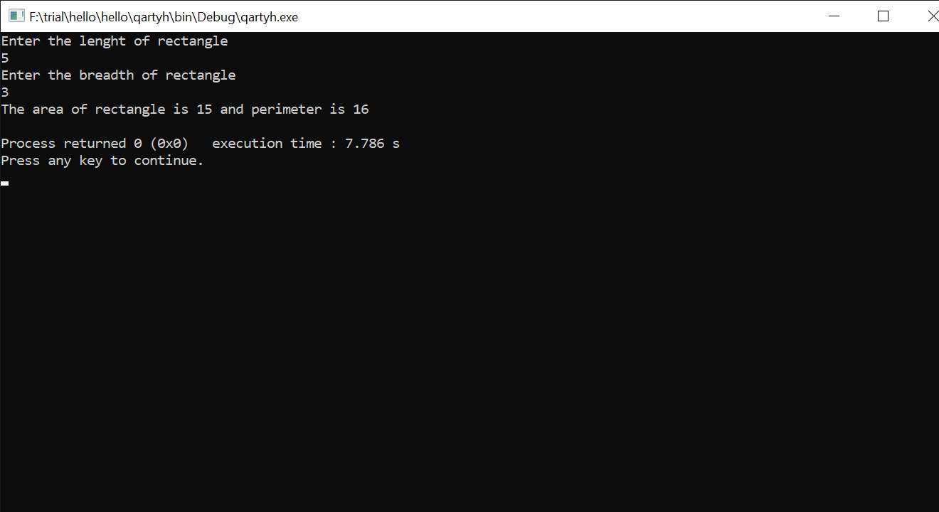

1. **Area and circumference of circle**

#include <iostream>

using namespace std;

int main()

{

int r;

cout<<"Enter the radius of circle"<<endl;

cin>>r;

float pi = 3.14;

float area = pi*r*r;

float circu = 2*pi*r;

cout<< "The area of circle is "<< area << " and circumference is "<< circu;

return 0;

}

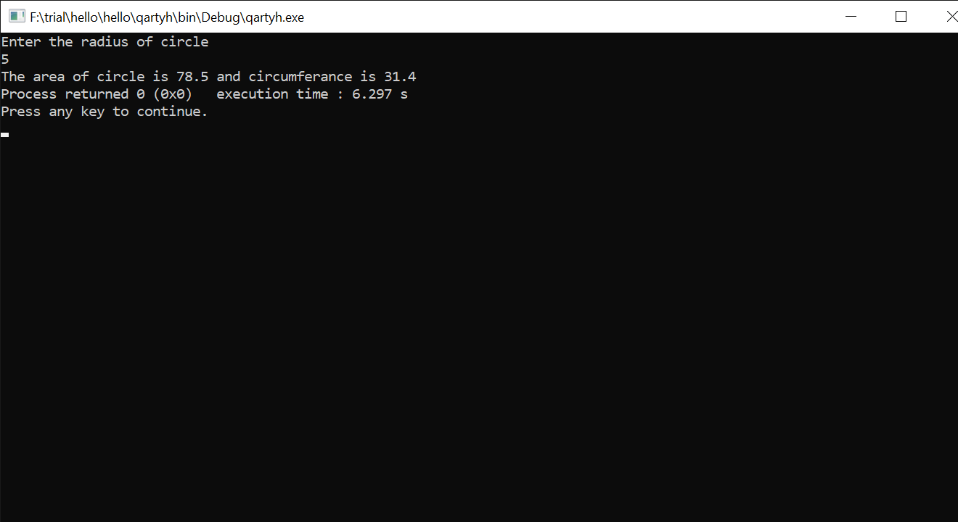

1. **Palindrome number check**

#include <iostream>

using namespace std;

int main() {

float t;

cout<<"Enter temperature in Celsius: ";

cin>>t;

cout<<"Temperature in Fahrenheit is "<<(9*t)/5+32<<endl;

cout<<"Enter temperature in Fahrenheit: ";

cin>>t;

cout<<"Temperature in Celsius is "<<((t-32)*5)/9<<endl;

return 0;

}

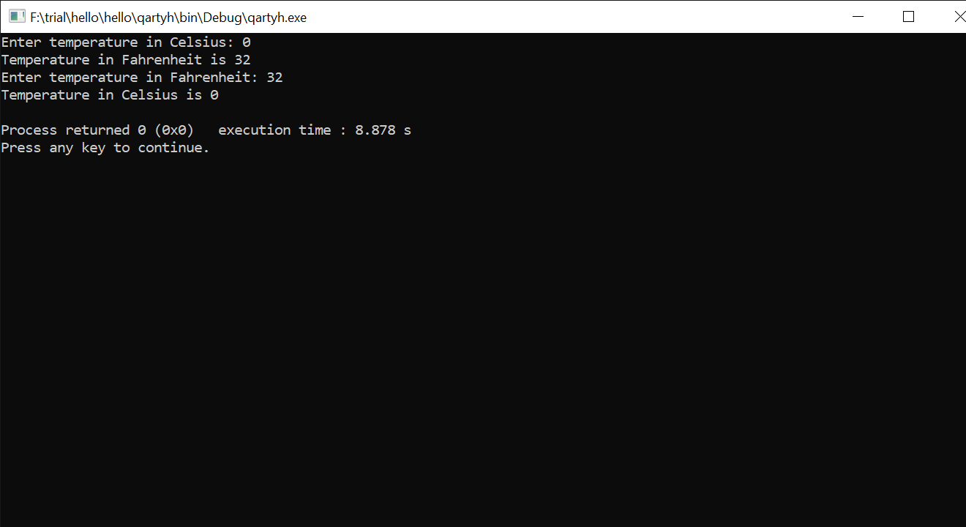

1. **Km to miles**

#include <iostream>

using namespace std;

int main() {

float t;

cout<<"Enter distance in kilometers/hour: ";

cin>>t;

cout<<"Distance in miles/hour "<<t/1.609<<endl;

return 0;

}

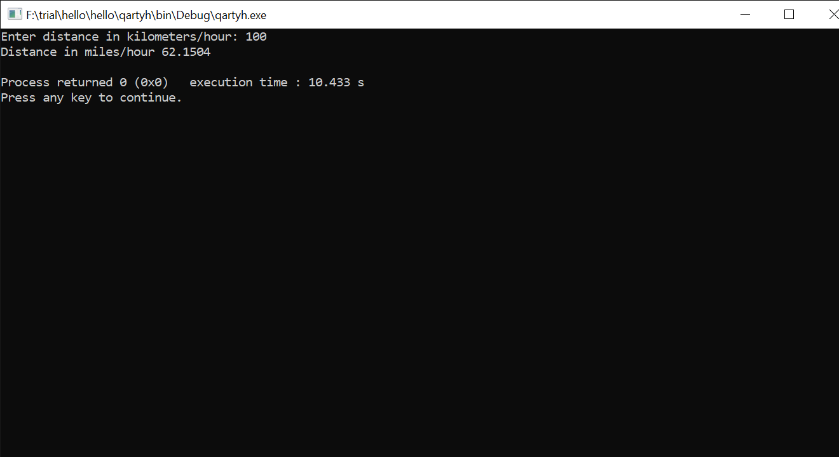

1. **Kelvin to Fahrenheit and vice versa**

#include <iostream>

using namespace std;

int main()

{

float kel, frh;

cout << " Enter the temperature in Kelvin : ";

cin >> kel;

frh = (9.0 / 5) * (kel - 273.15) + 32;

cout << "The temperature in Fahrenheit : " << frh << endl;

cout << "Enter the temperature in Fahrenheit : ";

cin >> frh;

kel=((frh-32)*5)/9 +273.15;

cout << "The temperature in Kelvin : " << kel << endl;

return 0;

}

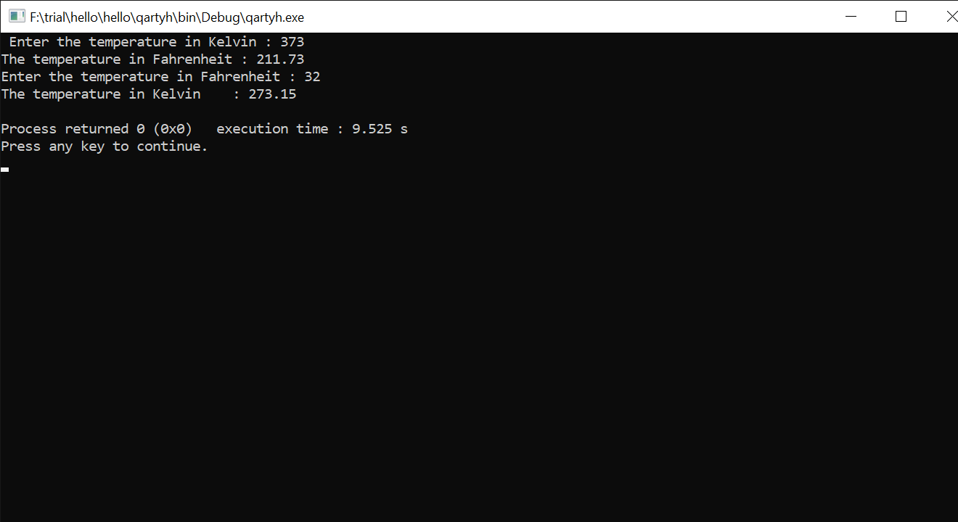

1. **Scalene triangle**

#include <iostream>

#include <math.h>

#define PI 3.14159

using namespace std;

int main()

{

float side1, side2, side3, area;

cout<<" Input the length of a side of the triangle : "<<endl;

cin>>side1;

cout<<" Input the length of another side of the triangle : "<<endl;

cin>>side2;

cout<<" Input the length of another side of the triangle : "<<endl;

cin>>side3;

float s=(side1+side2+side3)/2;

area = pow(s*(s-side1)*(s-side2)*(s-side3),0.5);

cout<<" The area of the Scalene Triangle is : "<< area << endl;

cout << endl;

return 0;

}

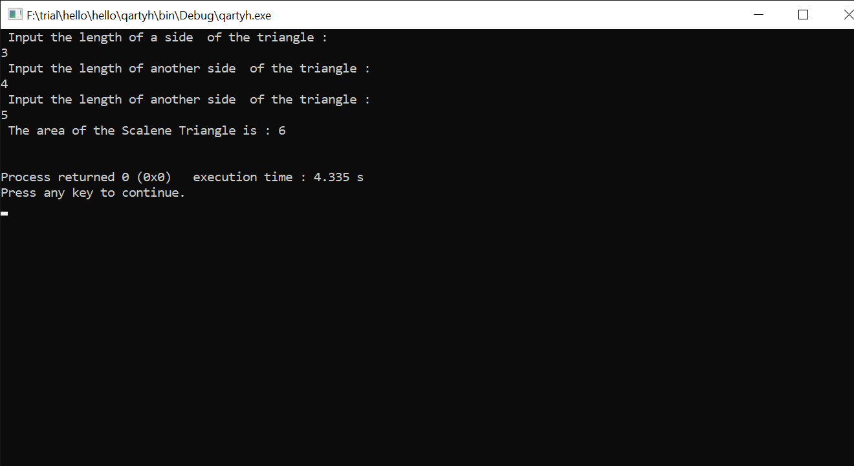

1. **Quotients and reminders**

#include <iostream>

using namespace std;

int main()

{

int divisor, dividend, quotient, remainder;

cout << "Enter dividend: ";

cin >> dividend;

cout << "Enter divisor: ";

cin >> divisor;

quotient = dividend / divisor;

remainder = dividend % divisor;

cout << "Quotient = " << quotient << endl;

cout << "Remainder = " << remainder;

return 0;

}

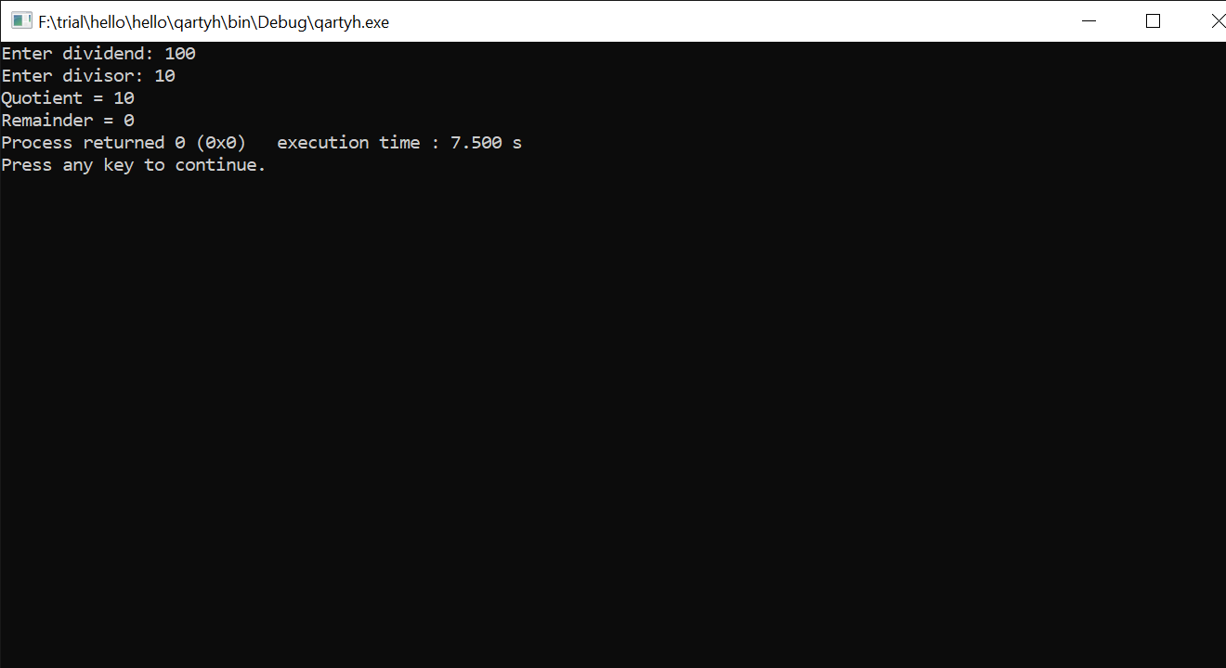

1. **Total and average of 4 numbers**

#include <iostream>

using namespace std;

int main()

{

float t[4];

cout << "Enter four numbers: ";

for(int i=0;i<4;i++){

cin>>t[i];

}

float sum=0;

for(int i=0;i<4;i++){

sum+=t[i];

}

cout<<"sum of all numbers: "<<sum<<endl;

cout<<"average is: "<<sum/4<<endl;

return 0;

}

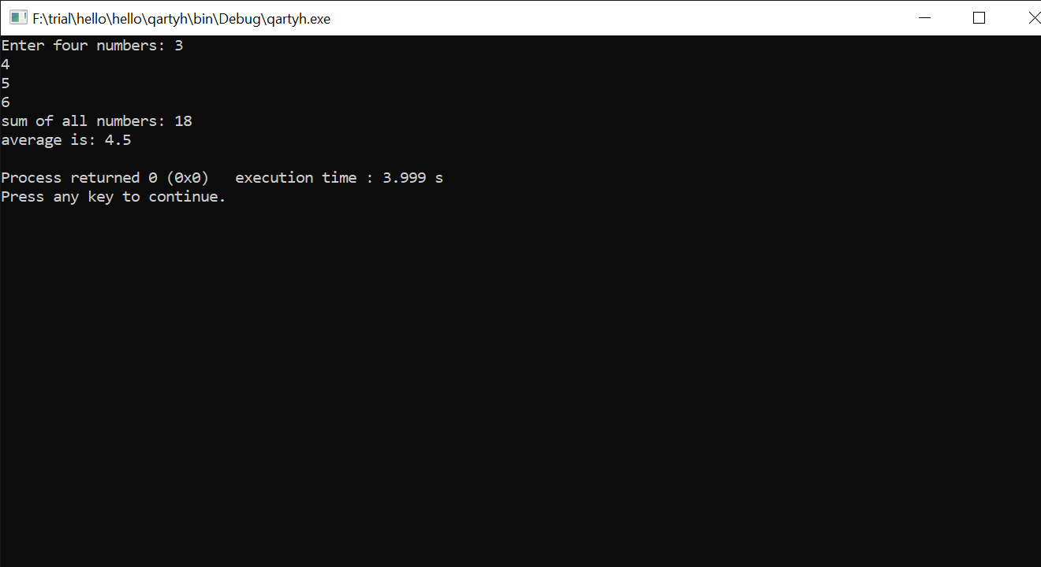

NAME – RAGINI SHARMA

ID – B120062

BRANCH - CSE